|  |  |
| --- | --- |
|  |  |

**Faculty of Technology and Engineering**

**Chandubhai S. Patel Institute of Technology (CSPIT)**

**Department of Computer Science & Engineering**

Date: / /

**Laboratory Manual**

|  |  |  |  |  |  |
| --- | --- | --- | --- | --- | --- |
| Academic Year | : | 2024-25 | Semester | : | 4 |
| Course code | : | CSE206 | Course name | : | DATABASE MANAGEMENT SYSTEM |

|  |
| --- |
| **Practical - 3** |
| **Aim: Global Trust Bank is expanding its operations and requires a robust database management system to efficiently manage its employees, job profiles, customers' accounts, and loan information. The bank has laid out specific requirements and constraints to ensure data integrity, uniqueness, and completeness. Perform Data Definition Language (DDL) commands and change the existing schema as per given information.**  **Constraints –**   * Not Null Constraints: Ensure critical fields are not null. * Unique Constraints: Ensure data integrity by limiting column values. * Check Constraints: Ensure columns like Account Number have unique values. |

**Tasks:-**

1. Retrieve all data from employee, jobs and deposit.

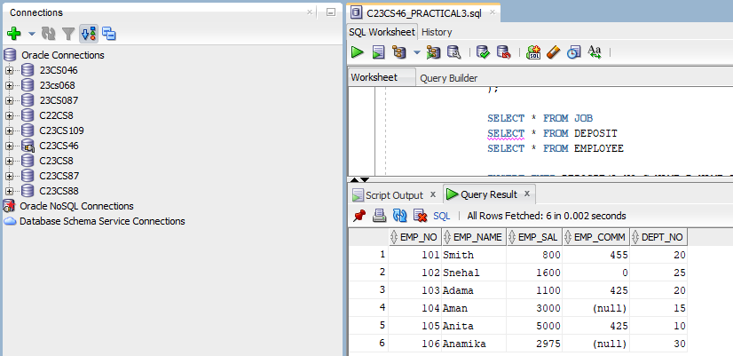

1. Display job title and maximum salary of all jobs.

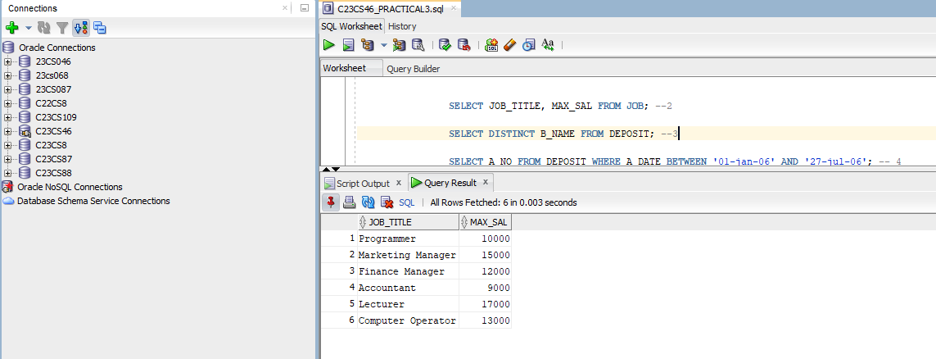

1. Write a query to find out all the branches.

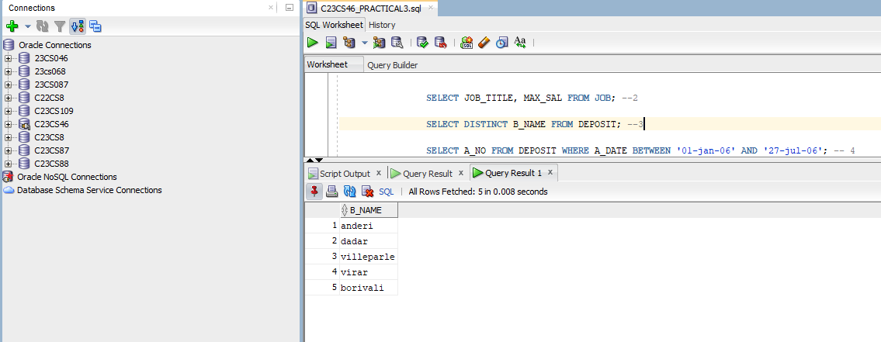

1. Display all the account no. into which rupees are between dates 01-01-06 and 25-07-06.

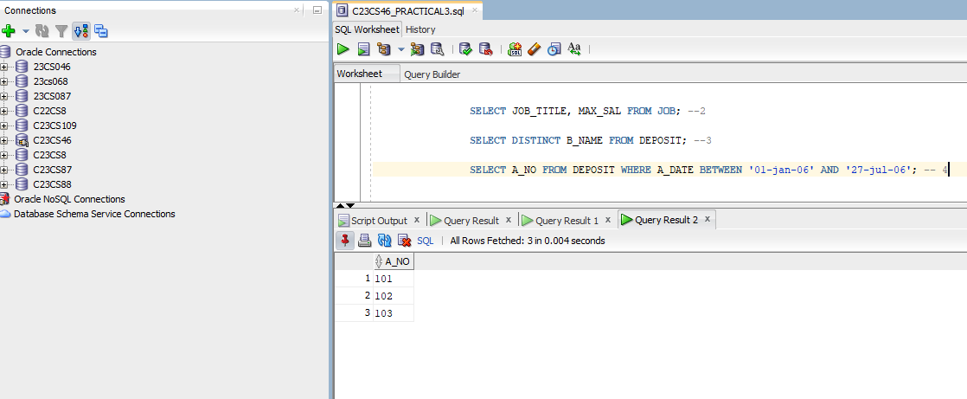

1. Display names of all customers whose account is deposited after 09-oct-06.

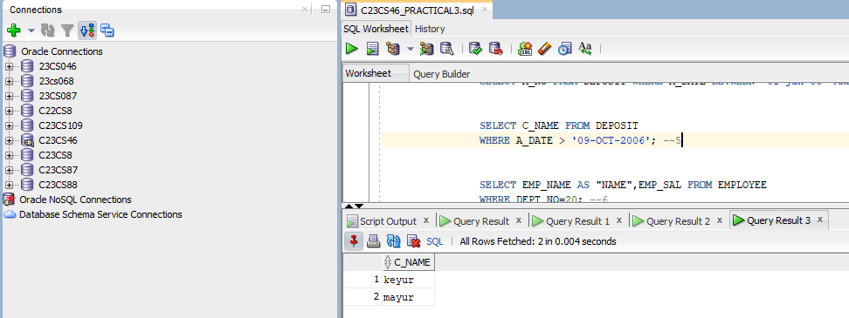

1. Display name and salary of employee whose department no is 20. Give alias name to name of employee.

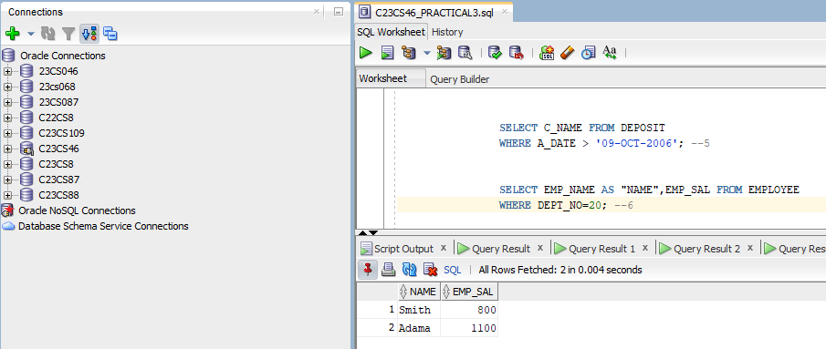

1. Display employee no, name and department details of those employee whose department lies in(10,20).

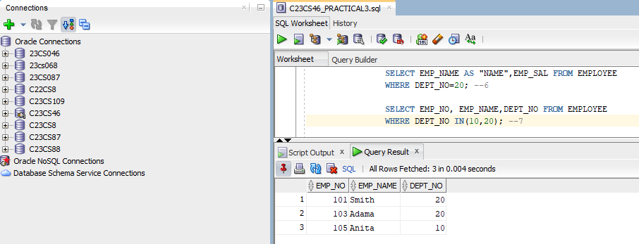

1. Display employee no, name and department details of those employee whose department not in(15,30) except 25 .

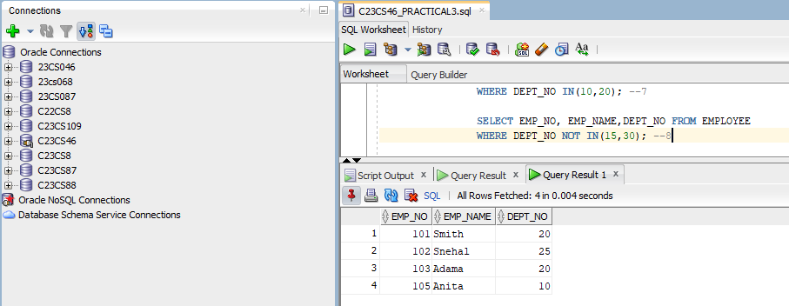

1. Display employee no, name and department details of those employee whose department no is between 15 and 25.

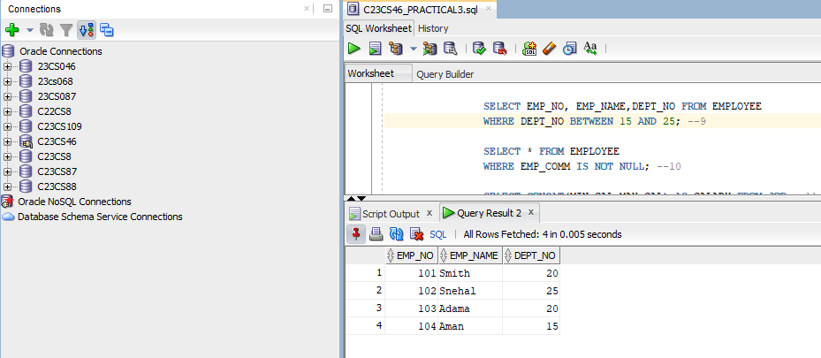

1. Display name of all employee whose emp_comm contains the non-null values.

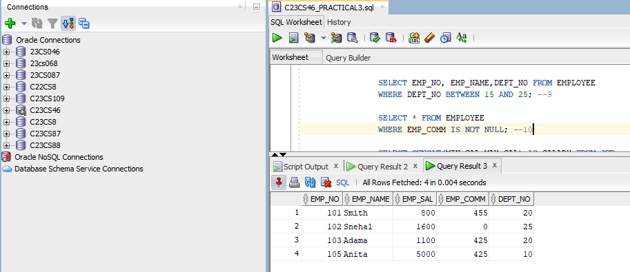

1. Combine min_sal and max_sal into a single column.

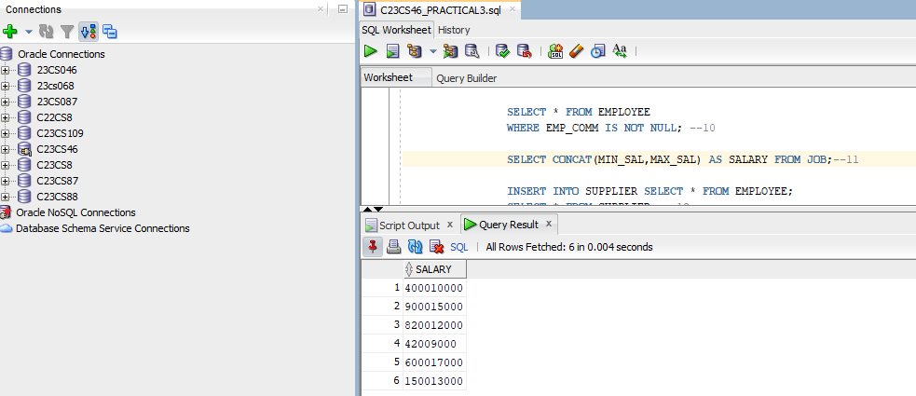

1. Insert the data into sup2 from employee.

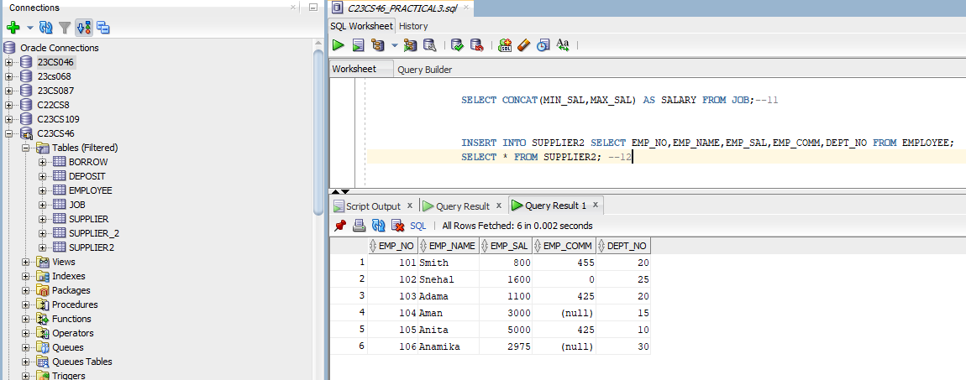

1. Delete all the rows from sup1 as sup.

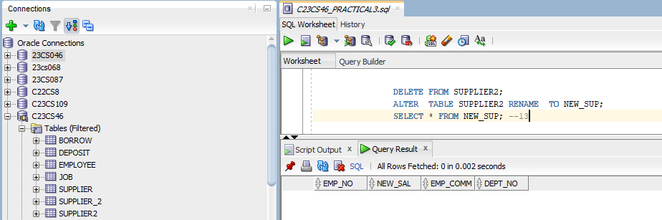

1. Delete the detail of supplier whose emp_no is 103.

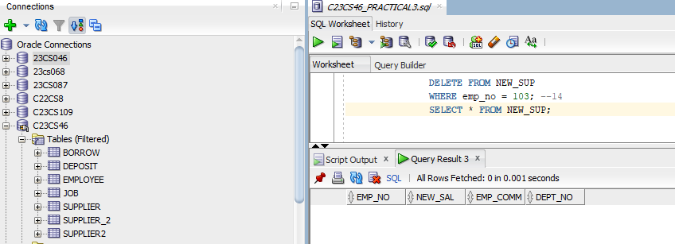

1. Update the name of employee to ‘Aman’ name whose emp_name is ‘Anita’.

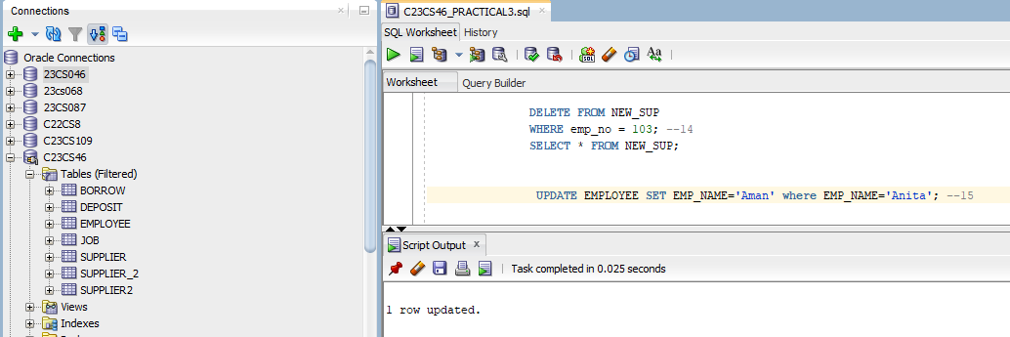

1. Update the value of employee name whose employee number is 103.

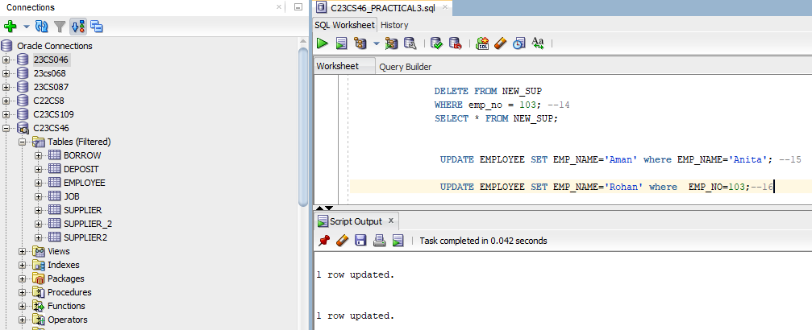

1. Find out the maximum and minimum salary form job table.

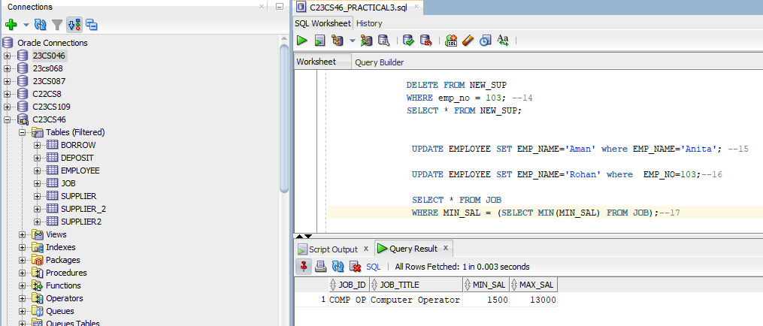

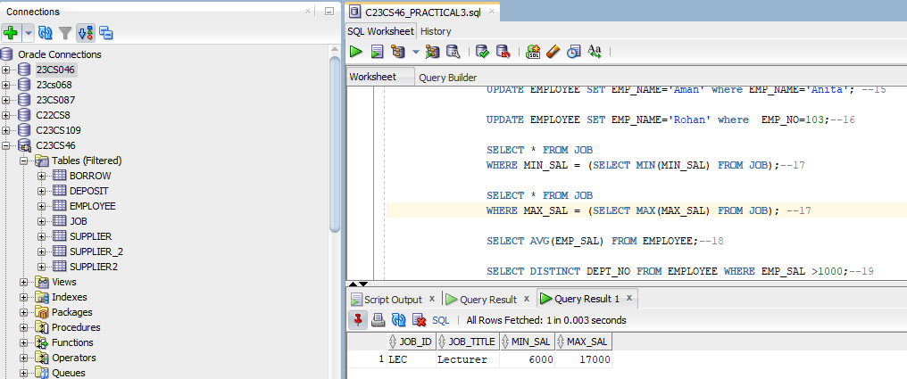

1. Find out the average salary of employee.

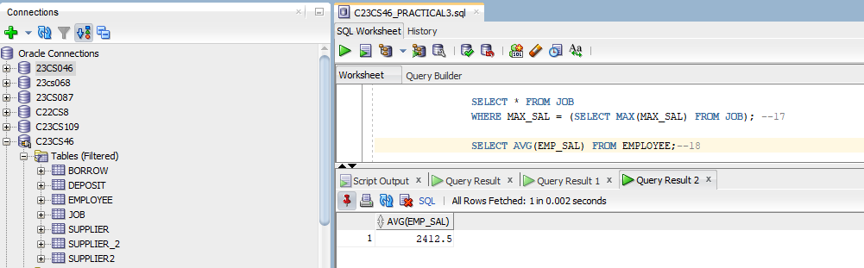

1. Count the total no as well as distinct rows in dept_no column with a condition of salary greater than 1000 of employee.

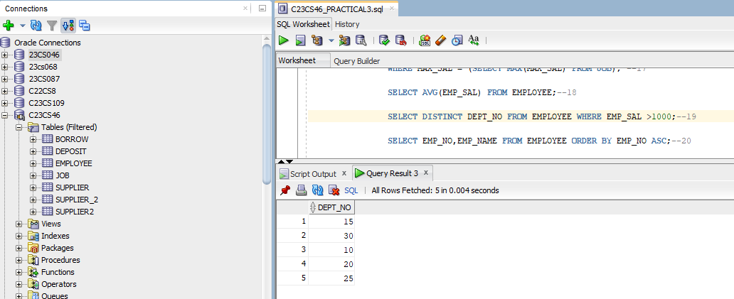

1. Display the detail of all employees in ascending order, descending order of their name and no.

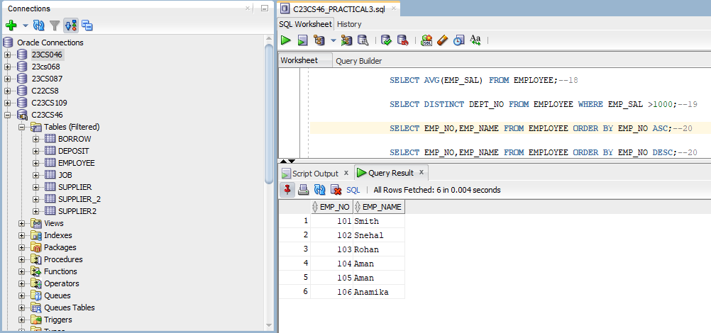

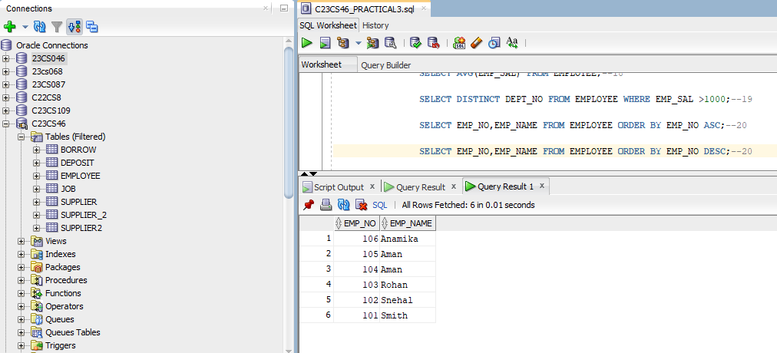

1. Display the dept_no in ascending order and accordingly display emp_comm in descending order.

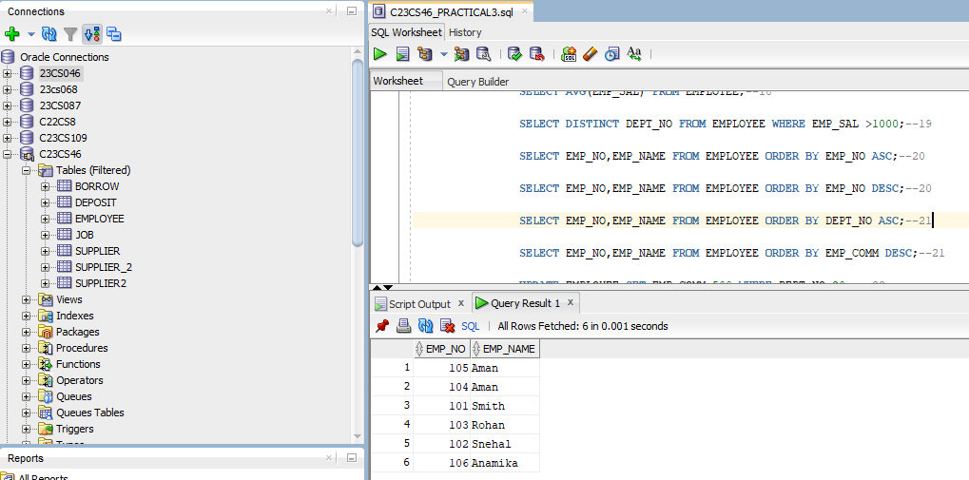

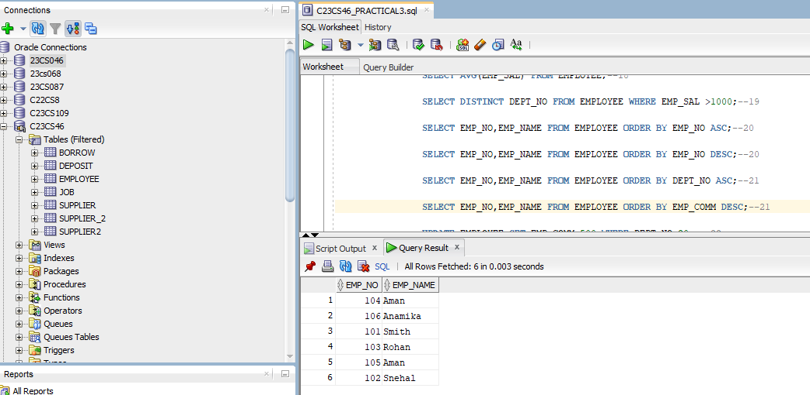

1. Update the value of emp_comm to 500 where dept_no is 20.

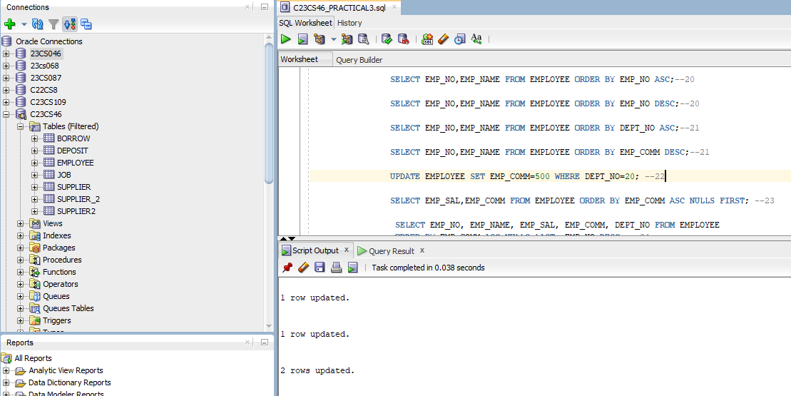

1. Display the emp_comm in ascending order with null value first and accordingly sort employee salary in descending order.

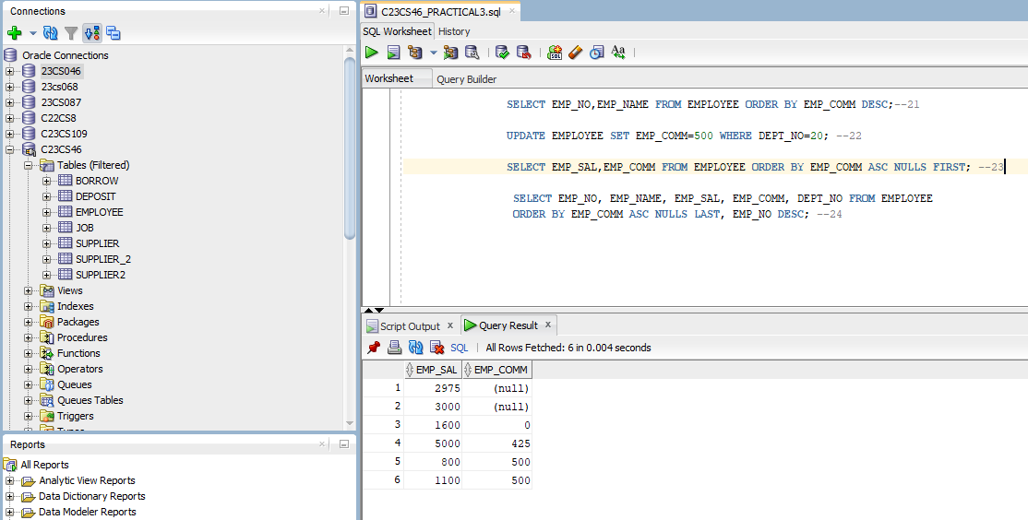

1. Display the emp_comm in ascending order with null value last and accordingly sort emp_no in descending order.

